**Kol Simcha Torah Gazette**

**For parsha ki seitzei 5785**

Volume 9 Issue 49 (Whole #463) 13 Elul 5785/ September 6, 2025

**Printed L’illuy nishmas Nechama bas R’ Noach, a”h**

For a free subscription, please forward your request to [***keren18@juno.com***](mailto:keren18@juno.com)

***Past emails can be found on the website ShabbosStories.com under Brooklyn Torah Gazette***

**16 Facts You Should Know About the Jews of Lebanon**

**By Rabbi** [**Yehuda Altein**](https://www.chabad.org/search/keyword_cdo/kid/17830/jewish/Altein-Yehuda.htm)

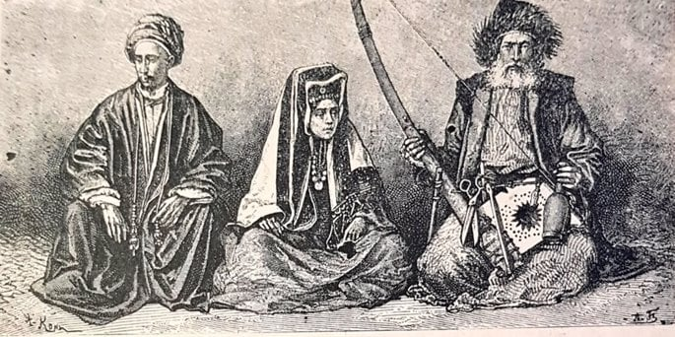

**Beiruti Jews in the 19th Century.**

*Just to the north of Israel lies Lebanon, a small, beautiful country with a long history of Jewish presence. Although the source of much terror activity in recent decades, surprisingly, not too long ago it was one of the most favorable Arab countries to live in as a Jew. Read on for 16 facts about the unique Jewish community of Lebanon.*

**1. Lebanon Was Once Part of Ancient Israel**

Believe it or not, the borders of ancient Israel, as described in the Torah, actually stretch into what is now modern-day Lebanon.[1](javascript:doFootnote('1a6999130');) That means the first Jews to live in the area were part of the original Israelite tribes who entered the land under Joshua’s leadership. Parts of today’s Lebanon belonged to the tribes of Dan, Naphtali, and Asher.

**2. Its Cedar Trees Were Used in the Holy Temple**

When King Solomon prepared to build the Holy Temple in Jerusalem, he turned to Hiram, the king of Tyre, for Lebanon’s world-famous cedar wood. Hiram happily agreed, sending massive rafts of cedar logs floating down the Mediterranean coast to [Jerusalem](https://www.chabad.org/library/article_cdo/aid/4246466/jewish/Jerusalem.htm).[2](javascript:doFootnote('2a6999130');) These majestic trees are mentioned often in the Bible—Psalms even likens the righteous to the lofty cedars of Lebanon.[3](javascript:doFootnote('3a6999130');)

Today, only a fraction of those ancient cedar forests remain. Some small groves still stand, with trees that are thousands of years old! One grove in the Chouf region is said to have been planted by Jews long ago, in the hope that its wood would one day be used to build the Third Temple.

**3. They Share Much in Common With Syrian Jews**

For much of history, Lebanon wasn’t its own country—it was part of broader empires and regions. As a result, Lebanese Jews developed customs and traditions very similar to those of neighboring Syrian Jewish communities, like Damascus and Aleppo.

**4. When Tragedy Struck, They Ran to Help**

In 1837, a terrible earthquake hit northern Israel, destroying the city of Safed and claiming thousands of lives. In a natural display of Jewish solidarity, a group of Jews from the Lebanese town of Deir al-Qamar (approximately 55 miles away) came to help, clearing rubble and helping bury the dead.

**5. The 20th Century Was a Time of Growth**

While there were always small Jewish communities in places like Sidon, Tripoli, Baalbek, and Hasbaya, things changed in the early 1900s. Lebanon became a destination for Jews from nearby countries like Syria, Iraq, and Turkey—and even from faraway Italy and Poland—thanks to its political stability and growing opportunities.

**6. French Influence Left Its Mark**

Between the two World Wars, Lebanon was under French rule. The French government promoted equal rights for the country’s many religious minorities, including Jews. As a result, French culture had a notable influence on Lebanese Jews, who often spoke both Arabic and French in their daily lives.

**7. Beirut Became a Center of Jewish Life**

As more Jews arrived in Lebanon, most settled in the city of Beirut, which became home to the largest concentration of Jews in the country. The center of the community was a Jewish neighborhood called Wadi Abu Jamil (or Wadi al-Yahoud—“Valley of the Jews”), where you could find synagogues, schools, charities, and even a Jewish cemetery.

**8. They Built Magnificent Synagogues**

At its height, there were 17 synagogues in Beirut, plus two more in Bḥamdoun and ʿAley, popular summer spots for Beirut’s Jewish families.

Lebanese Jews built many beautiful synagogues, some of which are still standing today. The most famous is the Maghen Abraham Synagogue in Beirut, commissioned by the Sassoon family in 1926. Though it was damaged in the 1980s, it has since been fully restored. Other historic synagogues include the Deir al-Qamar Synagogue, built in 1638 under the auspices of Druze leader Fakhr ad-Dīn Maʿan II, and the ancient Sidon Synagogue, which is over a thousand years old.

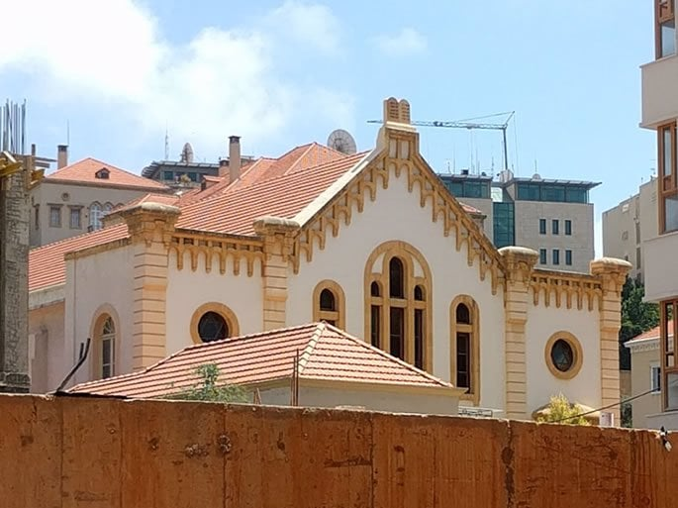

**Recent image of the Maghen Abraham Synagogue, in the Wadi Abu Jamil neighborhood.**

**9. It Was a Haven Among Hostile Arab States**

After Israel declared independence in 1948, Jews in many Arab countries faced violence and were forced to flee. But Lebanon was different: due to the favorable attitudes of many political leaders (such as Ignace Mobarak, Maronite Archbishop of Beirut), the Jewish community continued to thrive for another 20 years.

**10. They Made Pilgrimages to Zebulun’s Tomb**

One of the most ancient Jewish sites in Lebanon is the tomb of Zebulun—one of Jacob’s twelve sons—located in the port city of Sidon. In earlier times, Jews from all over Lebanon, and even from the Land of Israel, would make yearly pilgrimages to this holy site.

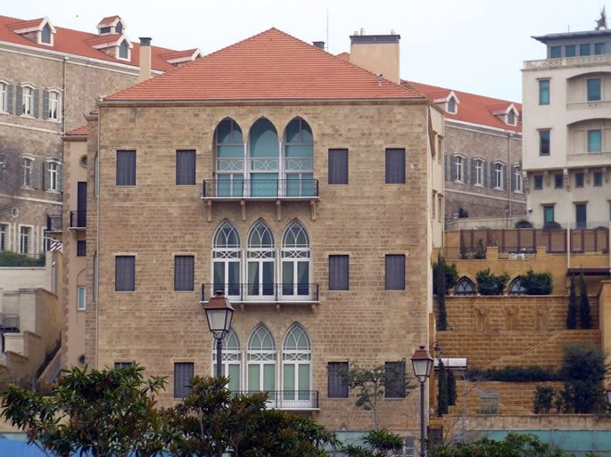

**Typical Lebanese houses in the Wadi Abu Jamil neighborhood.**

**11. Some Said Sidon’s Jews Should Keep Holidays Like Israel**

In Israel, Passover is celebrated with one Seder and holiday day, followed by *chol hamoed* (five intermediary days), capped off with one more holiday day. The same applies to Sukkot, and Shavuot is likewise only observed for one day. In the Diaspora, however, [Shavuot](https://www.chabad.org/library/article_cdo/aid/111377/jewish/Shavuot-2026.htm) is two days, and the holidays of [Passover](https://www.chabad.org/holidays/passover/default_cdo/jewish/Passover-Pesach-2025.htm) and [Sukkot](https://www.chabad.org/library/article_cdo/aid/4126/jewish/Sukkot-2025.htm) are observed for two days at either end of the intermediary days. Interestingly, since it is within the technical Biblical boundaries of the Holy Land, there was discussion in the 19th century as to whether the Jews of Sidon should keep one day or two.

**12. Visitors Called It “Gan Eden”**

With its breathtaking mountains, stunning Mediterranean coastline, and mild climate, Jewish visitors to Lebanon often exclaimed, “This place is *Gan Eden*—the Garden of Eden!” In fact, this accolade echoes the words of the prophet Ezekiel, who described the ancient city of Tyre as if it were in the Garden of Eden.[4](javascript:doFootnote('4a6999130');)

**13. Yom Kippur Concluded with a Special Fragrance**

Lebanese Jews kept many unique and beautiful customs. For example, on the first night of Rosh Hashanah, they would dip bread into sugar to herald in a sweet new year. During the concluding [Yom Kippur](https://www.chabad.org/library/article_cdo/aid/4687/jewish/Yom-Kippur-2025.htm) prayer of Ne’ilah, the Levites would wash the hands of the Kohanim with water soaked with orange blossom, uplifting the last moments of the fast with a refreshing fragrance.

**14. They Preserved a Unique Way of Koshering Meat**

Due to the prohibition against consuming blood, kosher meat is soaked, salted, and rinsed before cooking. An added element recorded in the Talmud[5](javascript:doFootnote('5a6999130');) was preserved by many generations of Lebanese Jewish women: after salting, they would “flash-boil” the meat, plunging it into boiling water, which would then be disposed of.

**15. The Safra Family Made a Global Impact**

One of the most prominent Jewish families to come from Lebanon is the Safra family. Originally from Syria, they moved to Lebanon in the 1910s and built a successful banking business. They gave generously to Jewish causes around the world, helping to build synagogues, support Jewish education, and more.

**16. Civil War Led to Mass Immigration**

After the Six-Day War in 1967, many Lebanese Jews began to leave, heading to Israel, the United States, Brazil, and France. Civil war in the 1970s led even more to emigrate. Today, only a small number of Jews remain in Lebanon.

Those who left have built strong communities in cities like Paris, Montreal, São Paulo, and New York, preserving the rich heritage and traditions of Lebanese Jews.

*The author thanks Rabbi Isaac Choua for his invaluable assistance in preparing this article.*

**Footnotes**

[1.](https://www.chabad.org/library/article_cdo/aid/6999130/jewish/16-Facts-You-Should-Know-About-the-Jews-of-Lebanon.htm" \l "footnoteRef1a6999130) See *Encyclopedia Talmudit*, vol. 2, p. 207.

[2.](https://www.chabad.org/library/article_cdo/aid/6999130/jewish/16-Facts-You-Should-Know-About-the-Jews-of-Lebanon.htm" \l "footnoteRef2a6999130) [I Kings 5:16](https://www.chabad.org/library/bible_cdo/aid/15889/jewish/Chapter-5.htm#v16)–28.

[3.](https://www.chabad.org/library/article_cdo/aid/6999130/jewish/16-Facts-You-Should-Know-About-the-Jews-of-Lebanon.htm" \l "footnoteRef3a6999130) [Psalms 92:13](https://www.chabad.org/library/bible_cdo/aid/16313/jewish/Chapter-92.htm#v13).

[4.](https://www.chabad.org/library/article_cdo/aid/6999130/jewish/16-Facts-You-Should-Know-About-the-Jews-of-Lebanon.htm" \l "footnoteRef4a6999130) [Ezekiel 28:13](https://www.chabad.org/library/bible_cdo/aid/16126/jewish/Chapter-28.htm#v13).

[5.](https://www.chabad.org/library/article_cdo/aid/6999130/jewish/16-Facts-You-Should-Know-About-the-Jews-of-Lebanon.htm" \l "footnoteRef5a6999130) [Chullin 111a](https://www.chabad.org/torah-texts/5463172/The-Talmud/Chullin/Chapter-8/111a). See Code of Jewish Law, Yoreh Deah 69:19.

*Reprinted from the current website of Chabad.Org*

**Rav Avigdor Miller on Thoughts**

**Upon Hearing the Shofar Blasts**

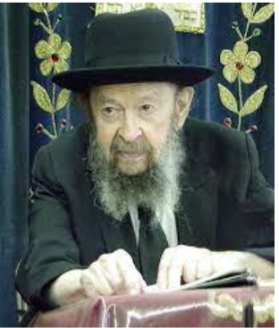

**QUESTION**: What should we think about during Chodesh Elul when we hear the shofar?

**ANSWER:** When you hear the shofar being blown there are many things to think about; not one thing. First-of-all you have to think היתקע שופר בעיר ועם לא יחרדו — Could it be that they blow a shofar in the city and the people are not afraid?! You have to be afraid right away! You have to be afraid; eimas hadin – fear of the judgement. It’s very important. The day is coming and you have to be afraid; you must be afraid.

Now, being afraid however has to have some practical results. You’re saying in slichos all the time something that you never do. נחפשה דרכינו ונחקורה – We will search out our ways. Do you search your ways? You never do it! Did you sit down for five minutes once in your life and search out your ways? Never! Oh, but he’s saying slichos; “nachpisa diracheinu v’nachkora.” Mmmmuh mmmmuh. He’s mumbling the words. What a pity.

So, the shofar says, “Start searching your ways!” At least five minutes. Five minutes by the way is a very small time to give to make an inventory on your business. A business man who makes a five-minute inventory will go broke. He needs much more than five minutes. But at least five minutes! At least you shouldn’t be a shakran. The whole world is deceiving Hashem. בפיו ובשפתיו כיבדוני – With his mouth and his lips he honors Me; he says “I will search out my ways,” ולבו רחק ממני – but his heart is far away from Me. He doesn’t think about it at all. It’s a terrible thing.

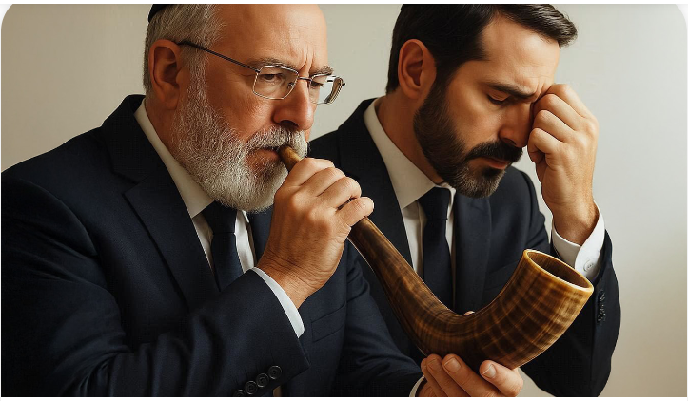

So, when you hear the shofar, think about your ways. Why is it that people, frum people, live their whole life in sin. He’s trying to kill his wife by saying mean words to her and she wants to shorten his life by saying mean words to him. They don’t want to do it chas v’shalom, but that’s what they’re doing – they’re hurting each other. A whole life of ona’as devarim. Each time you say it it’s a terrible sin. A terrible sin to say mean words to each other.

And it’s being done in so many houses! Nachpisah! If you search you’ll find. It’s terrible what’s going on in the houses. People hurt each other’s feelings tremendously. And don’t think it doesn’t have an effect on that person’s health. It affects the health; sure, it does. And therefore, there’s no lack of things to discover. Once you search, you’ll find. Oh yes, there’s plenty to find.

Another thought when you hear the shofar; the shofar has to remind you that b’chol yom v’yom bas kol yotzeis mei’har Sinai; every day a voice comes out from Har Sinai to remind you to learn Torah. The shofar blast reminds you of the shofar that we heard on Har Sinai. That’s one if the remazim of the shofar. Are you learning Torah? Are you interested in learning Torah? Are you reviewing what you learned? Even the daf yomi is not enough. It’s better than nothing but are you learning and trying to become a lamdan? It’s very important. Everyone can become a lamdan if he wants to. And Hashem requires that of you. He demands of you that you should become a lamdan.

Also, when you hear the shofar you should think, “We are recognizing Hashem as our King with the shofar blast.” אשרי העם יודעי תרועה. When you hear the shofar blow, you know that it means that the king is coming. It should remind you that Hashem is the melech ha’olam. You should think about that when they blow the shofar. Hashem is the melech ha’olam. He owns the world. He owns the street. He owns your house. He owns everything that you have. He owns the stars. He’s the Melech. He’s the owner of the world; it’s so important to feel that nothing is ours really – it’s only temporarily loaned to us for a short time. כי גרים ותושבים אתם עמדי.

We’re only visitors here for a short time. He is the owner; He is the Landlord. It’s always important to think about that.

And therefore, there are many lessons of the shofar, very many lessons. But whatever it is we should make use of it and not merely let it blow for nothing.

(October 1997)

*Reprinted from the current Eikev 5785 email of Torah Avigdor. (Tape #E-252 – November 2, 2000)*

*\*\*\*\*\*\*\*\*\*\*\*\*\*\*\*\*\*\*\*\*\*\*\*\*\*\*\*\*\*\*\*\*\*\*\*\*\*\*\*\*\*\*\*\*\*\*\*\*\*\*\*\*\*\*\*\*\*\*\*\*\*\*\*\*\*\**

*When you go forth to war against your enemies, and the L-rd your G-d will deliver him into your hand, and you have taken them captive* (Deut. 21:10)

These words refer to the descent of the soul, "a veritable part of G-d Above," into the physical world. Its mission, enclothed within a physical body, is to wage war and conquer the material world by infusing it with holiness, learning Torah and observing its commandments. This conflict will reach its successful conclusion with the coming of Moshiach, when G-dliness will reign triumphant. *(Peninei Hageula)*

*Reprinted from the Parshat Ki Seitzei 5762/2002 edition of L’Chaim*

**The Significance of the Two Enemies Facing Every Jew**

**From the Teachings of the Lubavitcher Rebbe**

**Rabbi Menachem Mendel Schneerson, Zt”l**

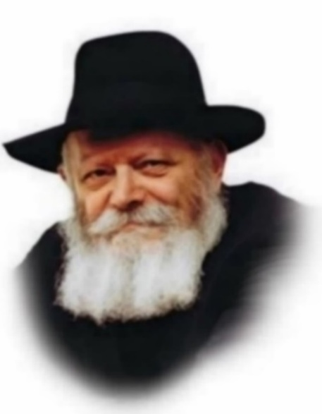

The first verse of this week's Torah portion, Ki Teitzei, seems to contain a grammatical error. "When you go forth to war against your enemies," it begins, "and the L-rd your G-d will deliver him into your hands." Why does the Torah begin the verse with the plural and continue in the singular?

Every word in the Torah is exact, every letter conveying a multitude of nuances and meanings which teach countless lessons. This verse, which seemingly deals with the subject of conventional warfare, alludes to a different type of war, a spiritual war which is waged by every individual.

A Jew may face two types of enemies: one which threatens his physical existence and one which threatens his special holiness as a member of the Jewish people - his Jewish soul.

The Torah uses the word "enemies" to refer to both these threats, for the body and soul of the Jew work in tandem, united in their service of G-d. Whatever imperils one's physical well-being threatens one's spiritual equilibrium, and vice versa.

The Torah tells us how to emerge victorious over both types of enemy: "When you will go forth." A person must gird himself with the strength that comes from absolute faith in G-d, even before encountering the enemy. Next, one's approach must be that of ascendancy - "against (literally, 'over') your enemies." Know that G-d Himself stands beside you and assists you in your struggle.

Armed in such a manner, victory is assured, not only against conventional enemies, but against the root of all evil - the Evil Inclination, equated in the Gemara with "the Satan (enemy of the soul), and the Angel of Death (enemy of the physical body)."

When a Jew goes out to "war" fortified with the knowledge that there is no force in the world able to stand in the face of goodness and holiness, not only are external manifestations of evil vanquished, but its spiritual source is defeated as well. The Torah therefore uses the singular - enemy - to allude to the Evil Inclination, the origin and prototype of all misfortune.

The verse concludes with the words "and you shall take captives of them." If a Jew is not careful and falls prey to the Evil Inclination, all of his higher faculties, given to him by G-d to be utilized for good, also fall into its snare. The Torah teaches that sincere repentance has the power to redeem these captive prisoners, elevating them until even "willful transgressions are considered as merits."

Such warfare brings Moshiach and the Final Redemption closer, when the Evil Inclination will be totally vanquished and the victory over sin will be permanent.

*Reprinted from the Parshat Ki Seitzei 5762/2002 edition of L’Chaim, a publication of the Lubavitch Youth Organization in Brooklyn, NY. Adapted from the teachings of the Lubavitcher Rebbe.*

*\*\*\*\*\*\*\*\*\*\*\*\*\*\*\*\*\*\*\*\*\*\*\*\*\*\*\*\*\*\*\*\*\*\*\*\*\*\*\*\*\*\*\*\*\*\*\*\*\*\*\*\*\*\*\*\*\*\*\*\*\*\*\*\*\*\**

*You shall not plow with an ox and a donkey together (Deut. 22:10)*

G-d has mercy on all His creations, big and small. The smaller donkey is unequal in strength to the mighty ox, and is unable to pull a plow with the same force. Yoking them together would cause the donkey to exert itself beyond its natural capacity, and is therefore forbidden. *(Ibn Ezra)*

*You shall not give interest to your brother...anything that is lent upon interest (literally, "anything that bites")* (Deut. 23:20)

Usury is likened to the bite of a serpent. Just as it takes the body a few minutes to react to a snake's poison, so too does it take time for the full effect of the compounding of interest to be felt by the borrower. *(Baal Haturim)*

*Reprinted from the Parshat Ki Seitzei 5762/2002 edition of L’Chaim*

**The Magical Island of Djerba**

**By Rabbi Mordechai Becher**

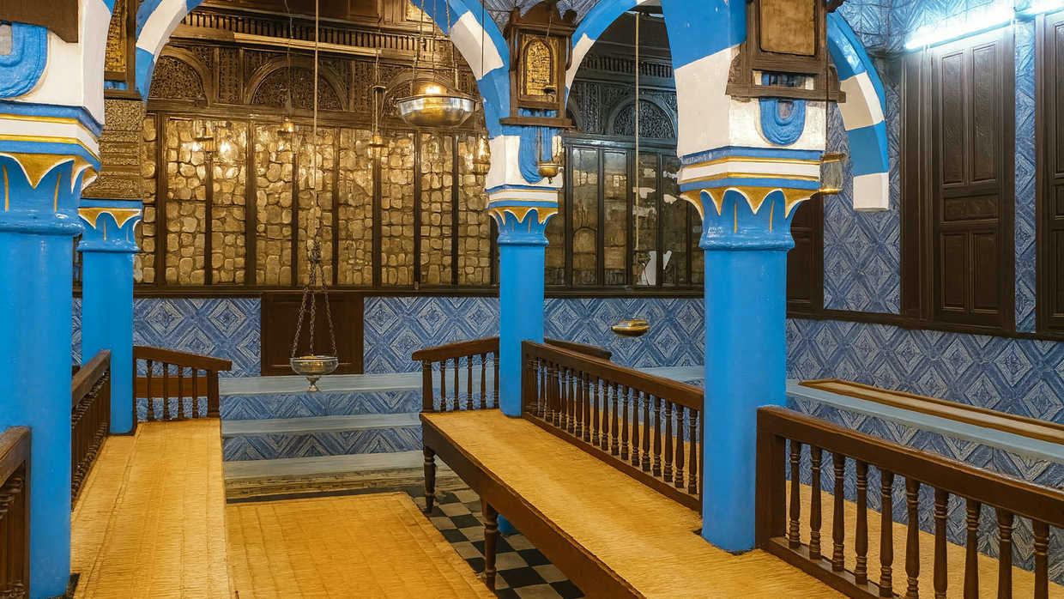

***Synagogue at the Tunisian island of Djerba.***

Journey to Djerba—an island where Judaism has flourished for 2,500 years, blending ancient Torah, vibrant tradition, and living faith in one of the world’s oldest Jewish communities.

Where did Jonah try to escape when he fled from G-d’s command?[1](https://aish.com/the-magical-island-of-djerba/#sdfootnote1sym) Where did King Solomon’s ships set sail to bring back ivory, monkeys, and peacocks?[2](https://aish.com/the-magical-island-of-djerba/#sdfootnote2sym) The Bible calls it *Tarshish*—a name wrapped in mystery and legend. Isaiah himself speaks of the mighty “ships of Tarshish.”[3](https://aish.com/the-magical-island-of-djerba/#sdfootnote3sym) But what if I told you that Tarshish may not just be a place in ancient text, but a land you can still walk upon today?

Jewish commentators across the centuries identified Tarshish with ancient Carthage[4](https://aish.com/the-magical-island-of-djerba/#sdfootnote4sym), the great North African power whose ruins still rest in modern-day Tunisia[5](https://aish.com/the-magical-island-of-djerba/#sdfootnote5sym). As a young yeshiva student first encountering the word *Tarshish*, I never imagined I would one day set foot there. Yet, about 15 years ago, I was blessed with the opportunity to travel as a scholar-in-residence with [Miriam Schreiber’s Legacy Kosher Tours](https://www.instagram.com/miriamslegacykoshertours/?hl=en)—and Tarshish became more than a word in the Bible. It became real.

**Tunisia: A Land of Wonders**

This past summer, I once again set out for Tunisia and I discovered something different: not just another exotic destination, but perhaps the most inspiring Jewish experience I have had outside the Land of Israel. And at the heart of it all lay the jewel of Tunisia: the island of Djerba.

Mainland Tunisia itself is a wonder. Imagine walking through a fully intact Roman coliseum, wandering an ancient city frozen in time, or driving from the endless golden sands of the Sahara Desert to lush groves of olives and dates. Tunis, the capital, boasts an active synagogue built in elegant Art Deco style—still active and serving the local Jewish community of about 300 people— a Jewish school, and even a kosher butcher. Incredibly, there’s a synagogue at a beach resort that still holds three daily prayer services throughout the summer.

*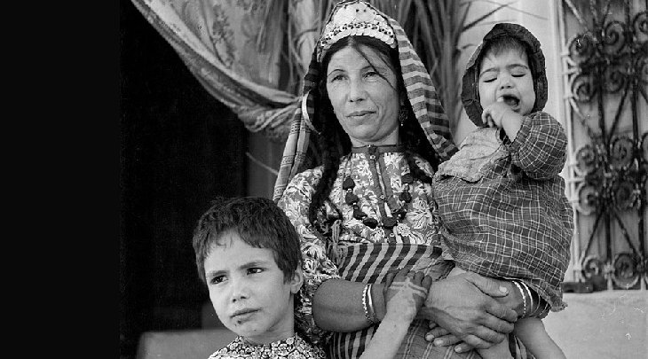****A Jewish woman and children outside a synagogue in Djerba, Tunisia (Wiki commons)***

**Djerba: The Living Gem of Jewish History**

The highlight of our trip to Tunisia was Djerba. [Djerba](https://aish.com/the-jews-of-djerba-9-facts-about-this-ancient-jewish-community/) is an island of about 200 square miles and a population of 185,000. The Jewish community on Djerba is about 1,300 strong and is arguably the oldest, continuous Jewish community in the world outside Israel.

It is believed that the first Jews arrived in Djerba after the destruction of the First Temple about 2,500 years ago. Those who came were mostly Cohanim, descendants of Aaron the High Priest, who brought with them a stone from the altar in the Temple and embedded it in the foundation of the Al Ghriba synagogue.

Today the Jewish population of Djerba is mostly Cohanim, and the Al Ghriba synagogue, albeit not the original building, is still a place of pilgrimage and prayer for Jews around the world. In the first and second centuries BCE, Jews settled in Djerba when it was first Carthage and then under the rule of the Roman Empire. After the destruction of the second Temple in 70 CE, more Jews came to Djerba where the community flourished under the Romans although experiencing some pressure under Byzantium.

*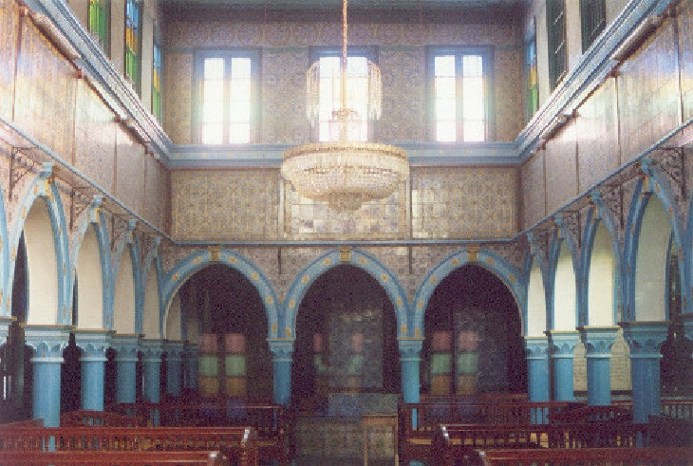****Inside the El Ghriba Synagogue***

Following the Arab conquest of North Africa, Jews in Djerba were granted *dhimmi* status — a protected but subordinate position under Islamic rule that required the payment of, *jizya*, a special tax. The Jewish community thrived, enjoying a degree of autonomy that allowed for the preservation of its religious and cultural identity.

**Tunisia as a Center of Torah**

During the medieval period, Tunisia emerged as a significant center of Torah study and served as a vital conduit for the transmission of Torah teachings from the academies of Babylon to the shores of the Mediterranean. Historical records mention the presence of prominent scholars from the academies of Babylon and Italy residing in Tunisia.

A well-known legend tells of four leading Torah scholars who were captured by pirates while traveling across the Mediterranean. These scholars were later ransomed by Jewish communities in Cordoba (Spain), Narbonne (France), Alexandria (Egypt), and Kairouan (Tunisia), thereby dispersing their knowledge across these important centers of Jewish life.

One of the most remarkable artifacts from this era is a letter preserved in the Cairo Genizah, written by a Gaon (Torah Sage) of Kairouan to a relative in Egypt, dated to the 10th century CE. Kairouan itself was home to a renowned yeshiva headed by Rabbi Yitzhak al-Fasi. He later relocated to Spain, where he established another influential yeshiva in Lucena. Among his distinguished students were Rabbi Yehuda Halevi and his close friend Rabbi Yosef ibn Migash. The latter became the teacher of Maimon, whose son—Moshe—became known to the world as Maimonides

By the 11th and 12th centuries, Djerba had become a notable center of Jewish scholarship and Kabbalistic activity. At the heart of this intellectual and spiritual life was the El Ghriba Synagogue, which emerged as a cornerstone of religious practice and tradition, drawing pilgrims and scholars alike. In the 15th and 16th Centuries after the expulsions from Spain and Portugal many refugees came to Tunisia bringing their Andalusian heritage and culture to North Africa.

**Ottoman and Colonial Periods**

In 1574, Djerba and the wider Tunisian region came under the control of the Ottoman Empire. Under the millet system, which allowed religious minorities to manage their own communal affairs, the Jews of Djerba maintained a distinct cultural and religious identity. This period of relative isolation helped preserve ancient traditions, including the use of the Judeo-Arabic language and the meticulous maintenance of priestly (Cohen) lineage.

The onset of the Colonial Period in 1881, when Tunisia became a French protectorate, brought profound changes. The influence of French culture and modernity introduced new educational opportunities, notably through schools established by the Alliance Israélite Universelle. These changes prompted some members of the Jewish community to seek economic or educational opportunities elsewhere, leading to migrations from Djerba to Tunis, France, and Algeria.

**Challenges of the Modern Era**

Following Tunisian independence in 1956, President Habib Bourguiba adopted a tolerant approach toward minorities, allowing the Jewish community to continue its religious life. However, in 1967, during the fallout of the Six-Day War, anti-Jewish riots broke out, triggering a significant wave of emigration — many Djerban Jews moved to Israel or France in search of security and stability.

Tragedy struck again in 2002 when Al-Qaeda orchestrated a terrorist bombing near the El Ghriba Synagogue, killing 21 people. This attack brought global attention to the community and raised serious security concerns, which subsequently were addressed by the Tunisian government.

**A Community Vibrantly Alive**

Today the Djerba community of about 1,300 preserves ancient traditions and lives with a sense of community and heritage that is rarely seen in the Diaspora. Our group visited the Jewish neighborhoods a number of times. They are home to numerous active synagogues, schools for boys and girls from kindergarten through high school, kosher restaurants and bakeries.

Today the Djerba community of about 1,300 preserves ancient traditions and lives with a sense of community and heritage that is rarely seen in the Diaspora.

One of the things that struck me most when visiting the Djerba community was the utterly natural way in which Judaism was practiced and experienced. There was no pretense or artifice—it was simply the fabric of their lives, the very skin in which they lived.

The sense of community was equally extraordinary. On Friday afternoons before Shabbat, teenagers would arrive at the communal bakery on motorbikes, carrying trays of challah dough prepared by their mothers. These were baked collectively by the entire community in preparation for Shabbat. Later in the day, they returned with their families’ *hamin*—the traditional Shabbat stew—which was placed in the communal oven on Friday afternoon and retrieved after synagogue services on Shabbat morning to be eaten for lunch.

About half an hour before Shabbat, the chief rabbi walks out to the public square and blows the shofar to announce its arrival. This beautiful custom dates back to the time of the Second Temple, when one of the priests would stand atop the Temple walls and blow six trumpet blasts to signal the people to close their shops, cease work, go home, prepare for Shabbat, and light their candles.

**Education and Torah Learning**

We visited the kindergarten, where the children were in the midst of reciting the *Shema*. The little girls wore traditional headscarves, like those worn by married women, and the boys donned miniature *tallitot*, just like their fathers. In the elementary school, children were studying the Torah—the Five Books of Moses—and translating it from Hebrew into Arabic, using the 10th-century translation of Rabbi Saadiah Gaon, known as the *Tafsir*.

At the boys’ high school, students were engaged in Talmud study, following the unique Djerban tradition. They first explored the Talmudic texts without commentaries, developing and articulating their own understanding of the ideas, which they then presented and debated with their teacher. Only after this process would they consult the commentaries of Rashi and Tosafot. They also devoted time each day to the study of *responsa* literature, gaining practical knowledge of Jewish law and developing familiarity with traditional rabbinic questions and answers. Although the girls' school was on vacation during our visit, we toured their beautiful new building. The interior—with its posters and decorations—reminded me of the Bais Yaakov girls’ high school in Passaic, where I live, except that the primary languages were Arabic and French.

**A Local Traditional Delicacy**

There are several kosher restaurants and snack stands in the community, so I was able to try a local traditional delicacy, called *brick*—a thin, round pastry filled with egg, parsley and spices, then deep-fried in olive oil.

There are approximately 50 *shochtim* (ritual slaughterers) in the community, many of whom regularly travel to larger Jewish communities to perform kosher slaughter. The *shochtim* of Djerba are renowned for their expertise and their uncompromising adherence to halachic standards. Additionally, there are numerous scribes in Djerba who produce and export Torah scrolls, *tefillin*, and *mezuzot* to Jewish communities around the world. Many of the Jews in Djerba are engaged in the trade of gold jewelry, and they enjoy an excellent reputation among the local population for their honesty and exceptional craftsmanship.

**Home to Many Great Torah Scholars**

As previously mentioned, Tunisia was home to many great Torah scholars, and numerous revered sages are buried there. We visited two of the cemeteries to pray at the gravesites of some of these distinguished figures. Many of these scholars wrote books that are still studied, many established customs that are still observed and many have descendants living deeply Jewish lives in Djerba.

This embodies the spirit of the Jewish community of Djerba. This is a community that has existed for over 2,000 years and remains vibrantly alive, faithfully preserving the ancient and beautiful traditions of our people on a relatively isolated island off the eastern coast of North Africa.

*Reprinted from the current website of aish.com*